**1. Set Up an Azure DevOps Project**

1. **Sign in to Azure DevOps**:
   * Go to [Azure DevOps](https://dev.azure.com/).
2. **Create a New Project**:
   * Click on **New Project**.
   * Provide a project name and description.
   * Choose visibility (Public or Private).
   * Click **Create**.

**2. Set Up a Repository**

1. **Navigate to Repos**:
   * Go to **Repos** in your project.
   * Either import an existing repository or create a new one.
2. **Add Your Code**:
   * Push your code from a local Git repository:

git remote add origin <repo-url>

git push -u origin main

**3. Define Your Pipeline**

Azure DevOps supports YAML pipelines, which are stored as a file (azure-pipelines.yml) in your repository.

**Basic Structure of azure-pipelines.yml:**

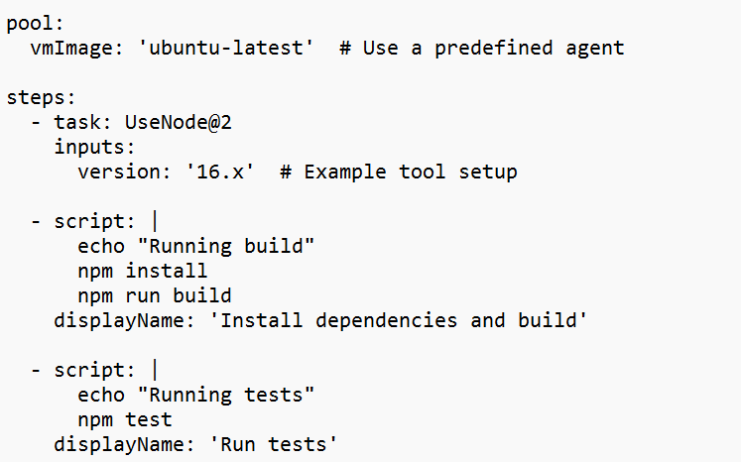

**4. Create the Pipeline in Azure DevOps**

1. **Go to Pipelines**:
   * In your Azure DevOps project, navigate to **Pipelines**.
2. **Create a New Pipeline**:
   * Click **Create Pipeline**.
   * Choose the repository containing your azure-pipelines.yml file.
   * Select **Existing Azure Pipelines YAML file**.
   * Follow the prompts to configure and save.

**5. Customize Your Pipeline**

Expand your pipeline with additional stages, jobs, and tasks as needed.

**Example: Multi-Stage Pipeline**

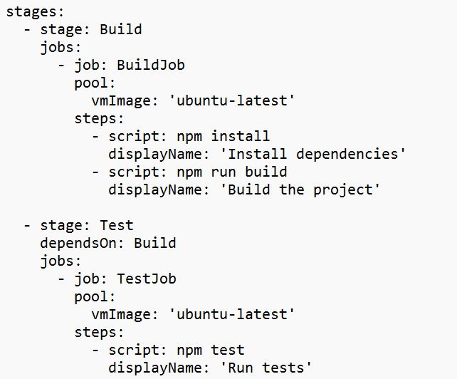

**6. Add Variables and Secrets**

1. **Pipeline Variables**:
   * Add variables directly in YAML or through the Azure DevOps UI.



1. **Secure Files and Secrets**:

Store sensitive data like API keys in **Library** or use **Azure Key Vault** for secure access.



**7. Run and Monitor the Pipeline**

1. **Run the Pipeline**:
   * Commit and push your azure-pipelines.yml.
   * The pipeline will trigger automatically if set up correctly.
2. **Monitor Progress**:
   * View logs and results under the **Pipelines** section in Azure DevOps.

**8. Troubleshooting and Optimization**

* **Pipeline Logs**: Inspect logs for errors.
* **Caching**: Use caching to speed up builds.
* **Templates**: Break pipelines into reusable templates for large projects.

